**OUTPUT 4C3S DECISION TREE**

**Criterion = “gini” max_depth = DEFAULT**

Accuracy: 0.678

Graph: Troppo grande

**Criterion = “gini” max_depth = 5**

Accuracy: 0.660

Graph:

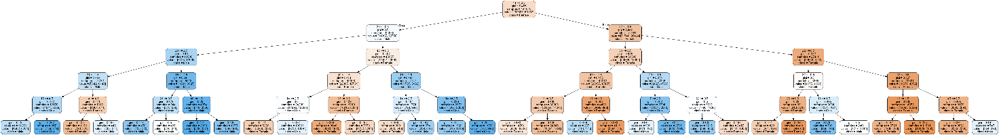

**Criterion = “gini” max_depth = 6**

Accuracy: 0.672

Graph:



**Criterion = “gini” max_depth = 7**

Accuracy: 0.684

Graph:

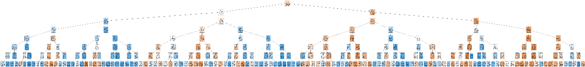

**Criterion = “gini” max_depth = 8**

Accuracy: 0.692

Graph:



**Criterion = “gini” max_depth = 9**

Accuracy: 0.700

Graph: Troppo grande

**Criterion = “gini” max_depth = 10**

Accuracy: 0.709

Graph: Troppo grande

**Criterion = “gini” max_depth = 11**

Accuracy: 0.713

Graph: Troppo grande

**Criterion = “gini” max_depth = 12**

Accuracy: 0.716

Graph: Troppo grande

**Criterion = “gini” max_depth = 13**

Accuracy: 0.719

Graph: Troppo grande

**Criterion = “gini” max_depth = 14**

Accuracy: 0.719

Graph: Troppo grande

**Criterion = “entropy” max_depth = DEFAULT**

Accuracy: 0.678

Graph: Troppo grande

**Criterion = “entropy” max_depth = 5**

Accuracy: 0.660

Graph:

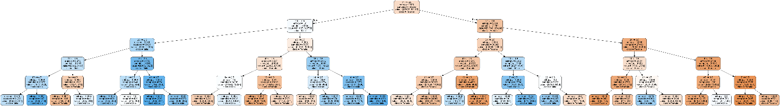

**Criterion = “entropy” max_depth = 6**

Accuracy: 0.672

Graph:



**Criterion = “entropy” max_depth = 7**

Accuracy: 0.684

Graph:



**Criterion = “entropy” max_depth = 8**

Accuracy: 0.692

Graph:



**Criterion = “entropy” max_depth = 9**

Accuracy: 0.701

Graph: Troppo grande

**Criterion = “entropy” max_depth = 10**

Accuracy: 0.708

Graph: Troppo grande

**Criterion = “entropy” max_depth = 11**

Accuracy: 0.713

Graph: Troppo grande

**Criterion = “entropy” max_depth = 12**

Accuracy: 0.715

Graph: Troppo grande

**Criterion = “entropy” max_depth = 13**

Accuracy: 0.715

Graph: Troppo grande

**OUTPUT 4C4S DECISION TREE**

**Criterion = “gini” max_depth = DEFAULT**

Accuracy: 0.69

Graph: Troppo grande

**Criterion = “gini” max_depth = 5**

Accuracy: 0.671

Graph:

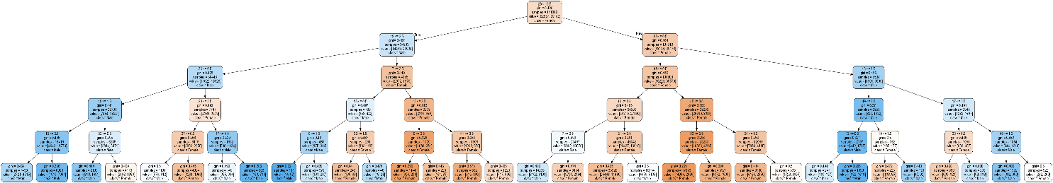

**Criterion = “gini” max_depth = 6**

Accuracy: 0.687

Graph:

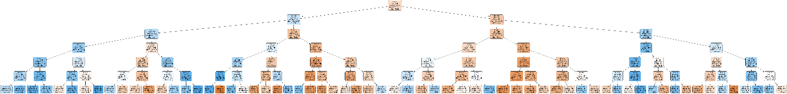

**Criterion = “gini” max_depth = 7**

Accuracy: 0.698

Graph:



**Criterion = “gini” max_depth = 8**

Accuracy: 0.705

Graph:



**Criterion = “gini” max_depth = 9**

Accuracy: 0.718

Graph:



**Criterion = “gini” max_depth = 10**

Accuracy: 0.726

Graph:



**Criterion = “gini” max_depth = 11**

Accuracy: 0.733

Graph: Troppo grande

**Criterion = “gini” max_depth = 12**

Accuracy: 0.735

Graph: troppo grande

**Criterion = “gini” max_depth = 13**

Accuracy: 0.738

Graph: troppo grande

**Criterion = “gini” max_depth = 14**

Accuracy: 0.736

Graph: troppo grande

**Criterion = “entropy” max_depth = DEFAULT**

Accuracy: 0.697

Graph: troppo grande

**Criterion = “entropy” max_depth = 5**

Accuracy: 0.679

Graph:

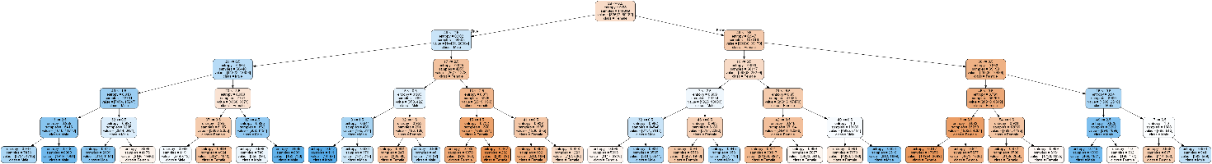

**Criterion = “entropy” max_depth = 6**

Accuracy: 0.693

Graph:



**Criterion = “entropy” max_depth = 7**

Accuracy: 0.699

Graph:



**Criterion = “entropy” max_depth = 8**

Accuracy: 0.713

Graph:



**Criterion = “entropy” max_depth = 9**

Accuracy: 0.721

Graph:



**Criterion = “entropy” max_depth = 10**

Accuracy: 0.730

Graph: Troppo grande

**Criterion = “entropy” max_depth = 11**

Accuracy: 0.733

Graph: Troppo grande

**Criterion = “entropy” max_depth = 12**

Accuracy: 0.737

Graph: Troppo grande

**Criterion = “entropy” max_depth = 13**

Accuracy: 0.737

Graph: Troppo grande

**OUTPUT 5C4S DECISION TREE**

**Criterion = “gini” max_depth = DEFAULT**

Accuracy: 0.513

Graph: Troppo grande

**Criterion = “gini” max_depth = 5**

Accuracy: 0.584

Graph:

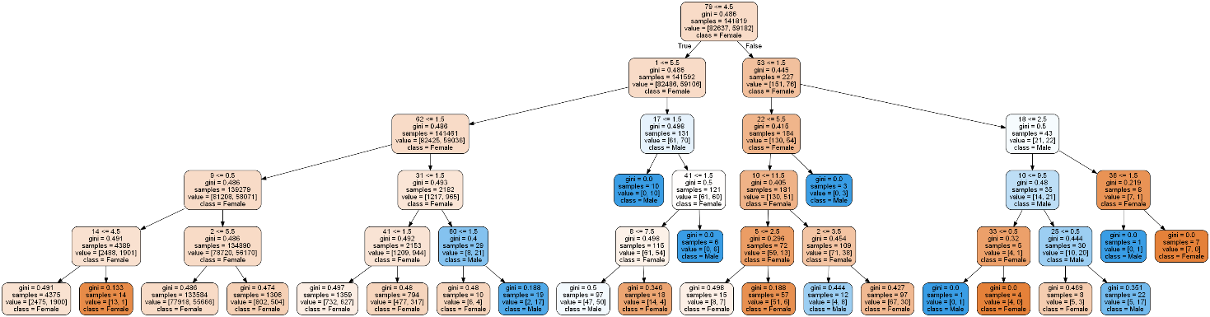

**Criterion = “gini” max_depth = 6**

Accuracy: 0.584

Graph:

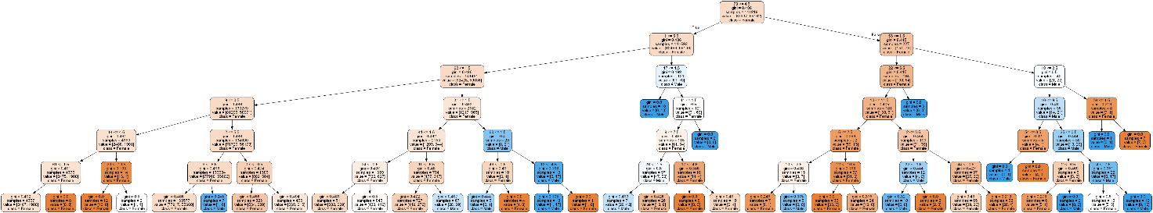

**Criterion = “gini” max_depth = 7**

Accuracy: 0.584

Graph:

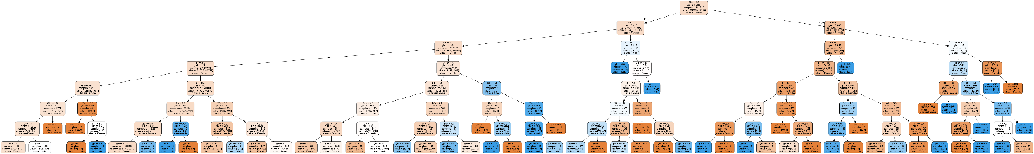

**Criterion = “gini” max_depth = 8**

Accuracy: 0.583

Graph:

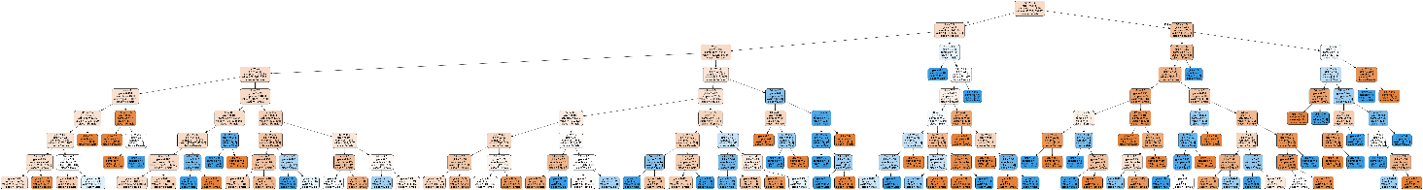

**Criterion = “entropy” max_depth = DEFAULT**

Accuracy: 0.514

Graph: Troppo grande

**Criterion = “entropy” max_depth = 5**

Accuracy: 0.584

Graph:

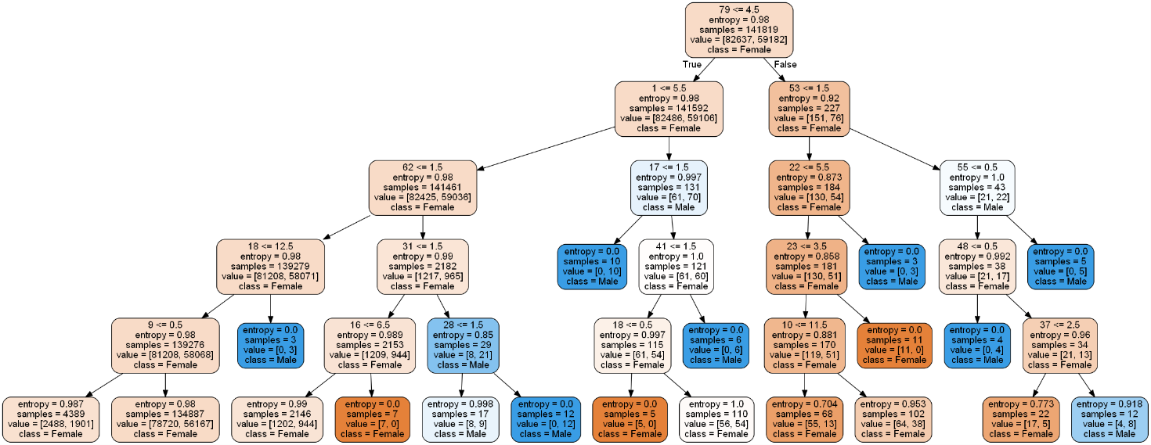

**Criterion = “entropy” max_depth = 6**

Accuracy: 0.584

Graph:

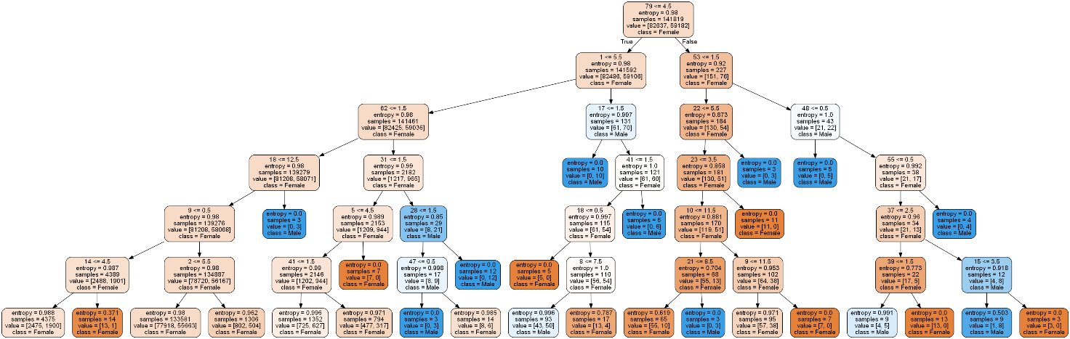

**Criterion = “entropy” max_depth = 7**

Accuracy: 0.584

Graph:

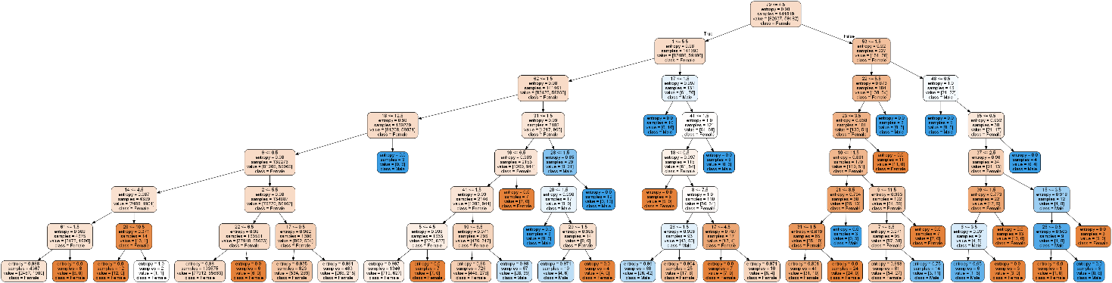

**Criterion = “entropy” max_depth = 8**

Accuracy: 0.583

Graph:

